|  |
| --- |
| WORKSHOP ASSIGNMENT |

|  |
| --- |
| GROUP 3: NAO ROBOT |

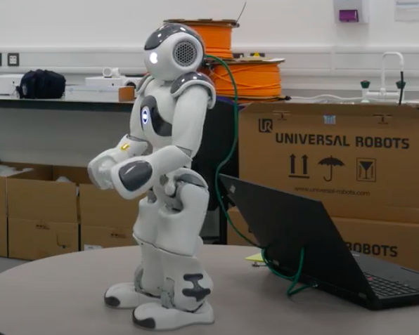

**Names of students:**

|  |  |
| --- | --- |
| Qualitative task | Quantitative task |
|  |  |
|  |  |
|  |  |
|  |  |
|  |  |

|  |
| --- |
| **WORKSHOP MONDAY, 17 JANAURY 2022** |

**Context**

You coded a **NAO** robot to support teaching English. Before such robots are deployed for use in schools, you are asked to consider and assess the associated human factors to ensure its adequacy with the target audience.

The link to your video can be found here: <https://drive.google.com/file/d/1ou8_Age8WUB7y4P0NeD_IrK8534Jbqwg/view>

**Your task**

1. Identify what factors/variables discussed today (cognitive and social) are involved in your scenario and how. List below all factors you can think of and for each, briefly explain why you think they are relevant.
2. Of all the factors, identify two that you would consider the most important.

Variable 1:

Variable 2:

|  |
| --- |
| **WORKSHOP TUESDAY, 18 JANUARY 2022** |

|  |
| --- |
| **Qualitative study** |

**Context**

You coded a **NAO** robot to support teaching English. You were asked yesterday to identify the most relevant variables that need to be checked before the **NAO** is deployed. In addition, identify what you intend to **qualitatively** investigate and what other variables could affect your data collection.

1. What you are looking to investigate?
2. How you are going to investigate it?
3. Think of potential additional variables that might come up and decide whether they should be accounted for, or identify an inclusion, exclusion criteria list with justifications. List them and provide details below. Then explain how they could affect your results.

|  |
| --- |
| **Quantitative study** |

**Context**

You coded a **NAO** robot to support teaching English in schools. You are asked to identify the most relevant variables that need to be checked for before **NAO** is deployed. In addition, think of how those variables can be affected by other factors.

**Your task**

1. Identify the independent variable and the dependant variable

Independent variable:

Dependant variable:

1. Write down one hypothesis using your independent and dependent variable.
2. Think of potential confounding variables and how to control for them. List them below and explain how they could affect your results.

|  |
| --- |
| **WORKSHOP WEDNESDAY, 19 JANUARY 2022** |

|  |
| --- |
| **Qualitative study** |

**Context**

You have to create the material for your study and decide who your participants would be if the study was carried out **for real**. In addition, assess the ethical issues that arise from your study.

**Your tasks**

1. What will be the focus of your questions?
2. Describe, in a step-by-step manner, what your participants will experience from the start of your data collection session (describe the procedure).
3. Based on the lectures, list at least 4 important ethical principles and explain how you would ensure the respect of each of them.
4. Create a **Word file** with your questions and a separate **consent form** (example on Canvas) ready to be emailed to your participants.
5. If the study were to be conducted face-to-face, identify your ideal sample (who would be your participants and why would you choose those individuals)?
6. Describe the recruitment phase (how would you recruit those participants detailed in the answer to question 5)

|  |
| --- |
| **Quantitative study** |

**Context**

You have to create the material for your study and decide who your participants would be if the study was carried out **for real**. In addition, assess the ethical issues that arise from your study.

**Your tasks**

1. How will you measure your variables?

How will you change your independent variable:

Measure of dependant variable:

1. Describe, in a step-by-step manner, what your participants will see from the moment they access the survey (describe the procedure).
2. Based on the lectures, list at least 4 important ethical principles and explain how you would ensure the respect of each of them.
3. Ensure that you have all surveys and the **consent form** (example on Canvas) in the correct place and order and the links are set up ready for your experiments in the morning. We will provide some materials on Canvas for you to access.
4. If the study were to be conducted face-to-face, identify your ideal sample (who would be your participants and why would you choose those individuals)?
5. Describe the recruitment phase (how would you recruit those participants detailed in the answer to question 5)

|  |
| --- |
| **WORKSHOP THURSDAY, 20 JANUARY 2022** |

|  |
| --- |
| **Qualitative and Quantitative studies** |

**Your task**

1. Collect the data

|  |
| --- |
| **WORKSHOP FRIDAY 21 JANAURY 2022** |

|  |
| --- |
| **Qualitative and Qualitative studies** |

**Context**

You now have to run your study, analyse your data, assess your results in a critical way and present your study to the rest of the class.

**Your task**

1. Analyse your data
2. Find flaws in your study and find ways to correct such issues in future research
3. Prepare a 12-minute PowerPoint presentation presenting both your qualitative and quantitative studies

* Discuss the implications of your task in another area of robot application (social, manufacturing, transport, etc.) and adaptions you may make as a result.
* What implications do you foresee from this?